**Why to add Bias in Neural Network?**

In a neural network, **bias** is added to neurons to help models capture patterns more effectively. Here's why:

1. **Increased Model Flexibility**: Without a bias, the output of a neuron is strictly zero when the input is zero (since it's a weighted sum of the input). Adding bias allows the neuron to have a non-zero output even when the input is zero, increasing its flexibility.
2. **Shift Activation Functions**: Many activation functions (like sigmoid, ReLU, etc.) have behavior that depends on the input values. Bias helps shift the activation function left or right, allowing the model to better fit the data by adjusting the threshold at which neurons become active.
3. **Improves Learning Capacity**: Bias terms allow the network to better fit the training data by providing more control over the model. It enables the model to learn patterns more effectively by adjusting how sensitive a neuron is to incoming inputs.

Mathematically, a neuron computes:

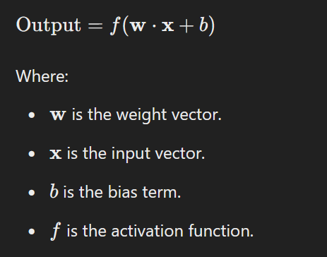

Without bias, the neural network might struggle to learn complex patterns, especially in cases where an offset or shift is needed for better prediction.

Why to Add Bias: <https://www.turing.com/kb/necessity-of-bias-in-neural-networks>

<https://www.geeksforgeeks.org/effect-of-bias-in-neural-network/>

<https://deeplizard.com/learn/video/HetFihsXSys>